Chapter 5, Solution 66.

We can start by looking at the contributions to v_{o} from each of the sources and the fact that each of them go through inverting amplifiers.

The 6 V source contributes –[100k/25k]6; the 4 V source contributes
–[40k/20k][–(100k/20k)]4; and the 2 V source contributes –[100k/10k]2 or

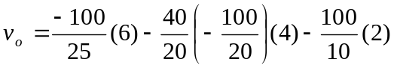

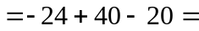 –4V

